

**Social Media Analysis**

**Project By – Dhanush S**

**TABLE OF CONTENT**

|  |  |
| --- | --- |
| **SL_NO** | **CONTENT** |
| **1** | **Schema** |
| **2** | **Objective Questions** |
| **3** | **Subjective Questions** |

**SCHEMA**

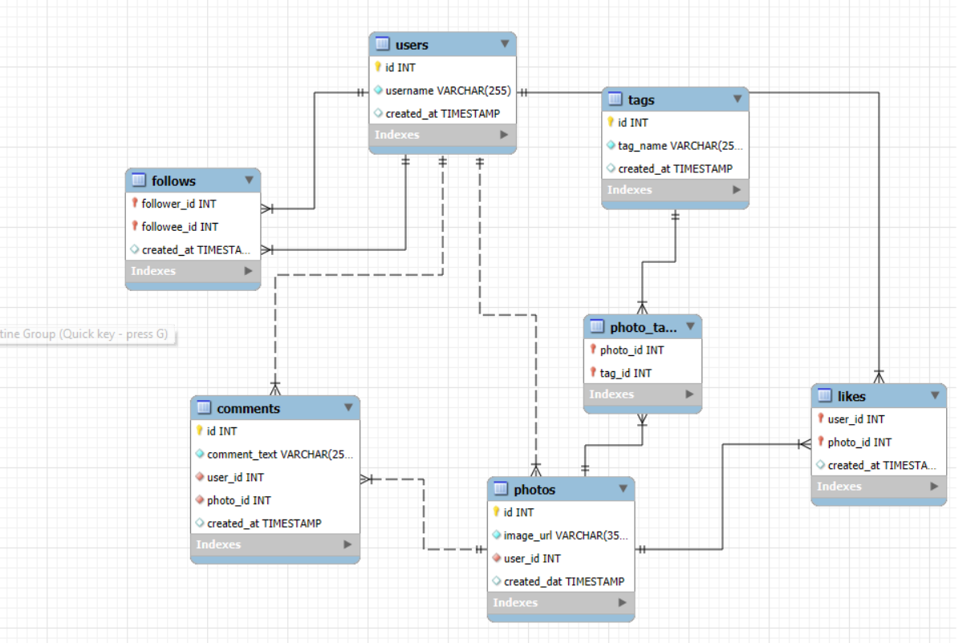

**Data Description**

* comments_id : unique identifier for each comment
* comment_text : text content of a given comment
* user_id : unique identifier for each user
* photo_id : unique identifier for each photo
* created_at : date of interaction in the form like, photos, tags
* follower_id : user_id of the follower for a certain user
* followee_id : user_id of followee for a certain user
* tag_id : unique identifier for each tag
* image_url : link to the image posted on the platform
* username : username chosen by the user

**OBJECTIVE QUESTIONS**

1. **Are there any tables with duplicate or missing null values? If so, how would you handle them?**

**Ans** - To check for duplicate or missing NULL values, the following queries can be used. This approach can be applied across various tables in the dataset. Upon reviewing each table, it was confirmed that there are no duplicates or missing NULL values in any of the tables.

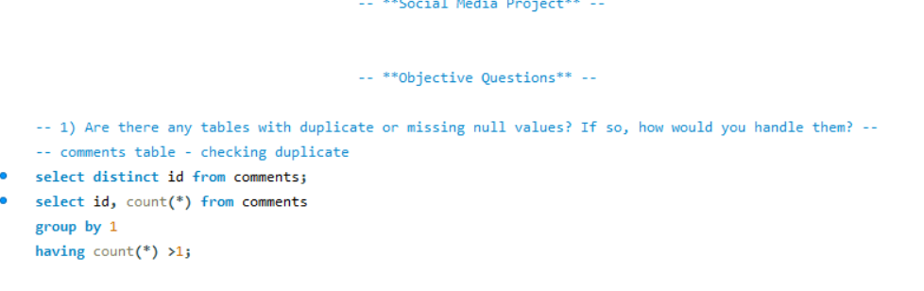

To identify duplicate values, I used a query that groups the data by the unique "id" column and employs a HAVING clause to pinpoint records that appear more than once.

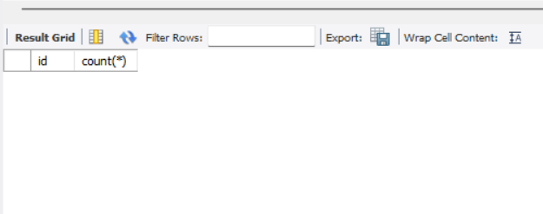

To locate rows with null values, I use a WHERE clause that specifically checks for the presence of null entries.

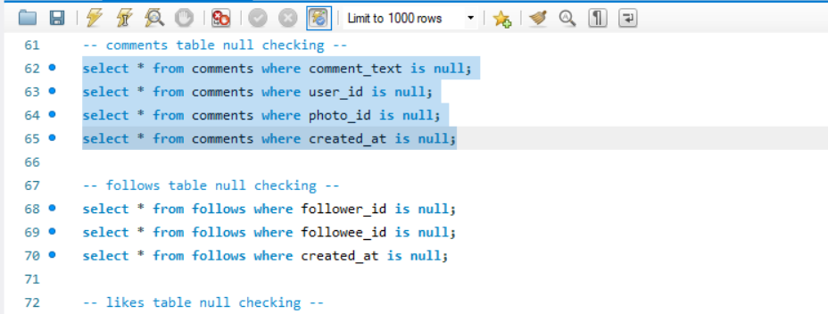

1. **What is the distribution of user activity levels (e.g., number of posts, likes, comments) across the user base?**

**Query:**

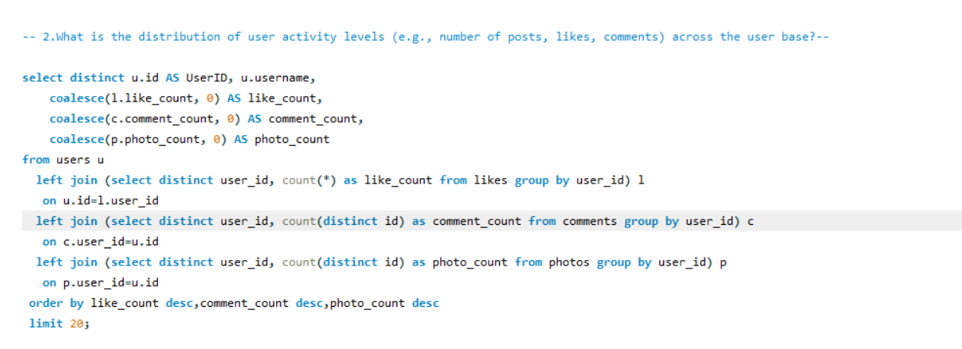

**Ans -**This query counts the number of posts, likes, and comments for each user, including those with no posts, likes, or comments. A "LEFT JOIN" is used to connect the likes, comments, and photos tables with the users table.

**OUTPUT**

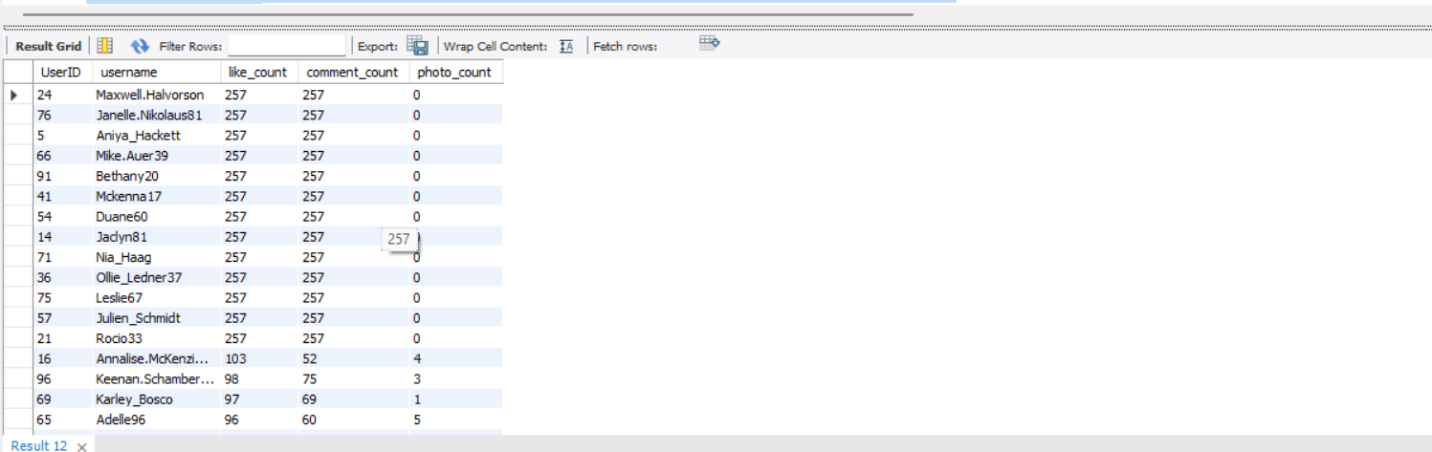

1. **Calculate the average number of tags per post (photo_tags and photos tables).**

**Ans-** This query first calculates the count of tags for each photo in a subquery and then computes the average tag count as avg_num_tags.

**Query:**

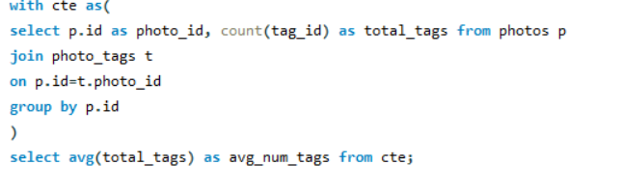

**OUTPUT**

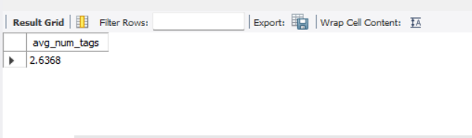

1. **Identify the top users with the highest engagement rates (likes, comments) on their posts and rank them.**

**Ans-** This query counts the number of likes and comments for each post and creates a view for future use. User engagement is calculated by summing the likes and comments, then dividing by the total number of posts. "DENSE_RANK" is used to rank users based on their engagement rate, considering only users who have posted at least one photo. A "LEFT JOIN" is employed to connect the users table with the other relevant tables.

**Query:**

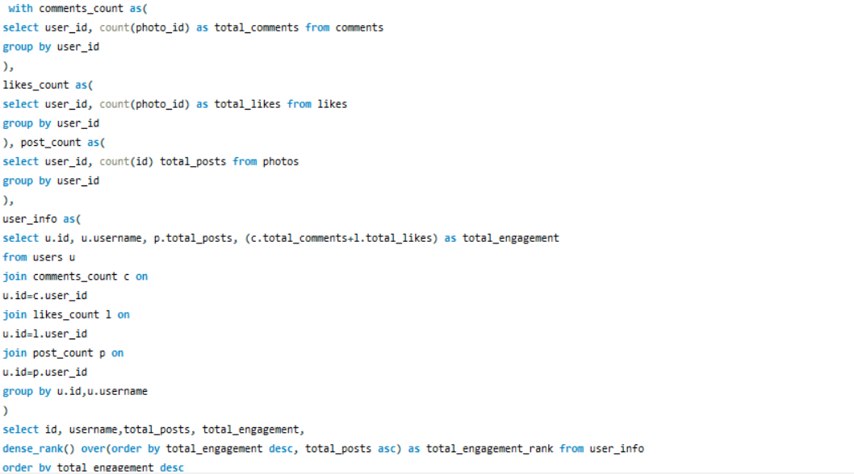

**OUTPUT**

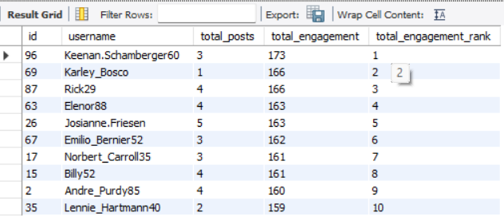

1. **Which users have the highest number of followers and followings?**

**Ans-** This query retrieves the user's ID, username, and their follower or following count. The "LIMIT" clause is used to return only the first user in the specified order.

**Query:**

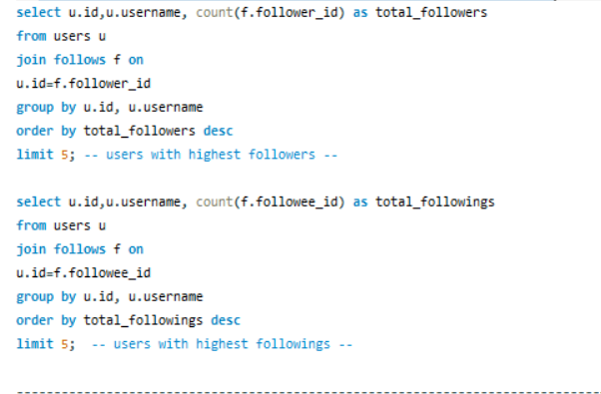

**OUTPUT**

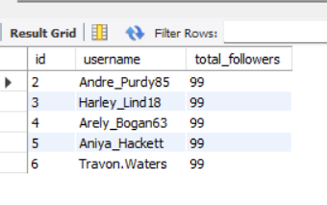 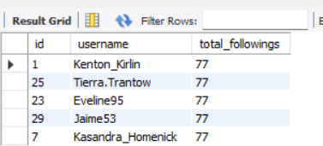

1. **Calculate the average engagement rate (likes, comments) per post for each user.**

**Ans-** This query calculates the engagement rate similarly to Objective Question 4, using the formula: (total likes + total comments) / total posts. It retrieves the user ID, username, and engagement rate for users who have made at least one post.

**Query:**

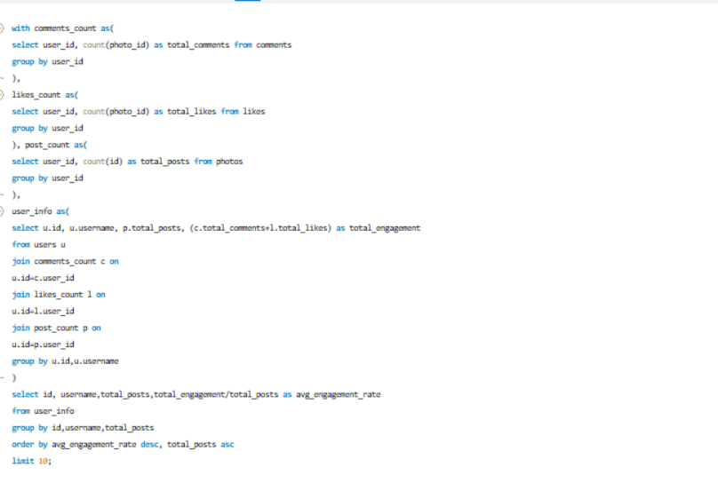

**OUTPUT**

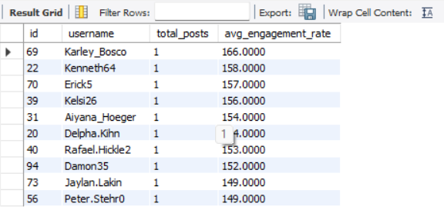

1. **Get the list of users who have never liked any post (users and likes tables)**

**Ans-** This query retrieves the ID and username of users whose IDs are not present in the likes table. A "LEFT JOIN" is used to link the users table with the likes table.

**Query:**

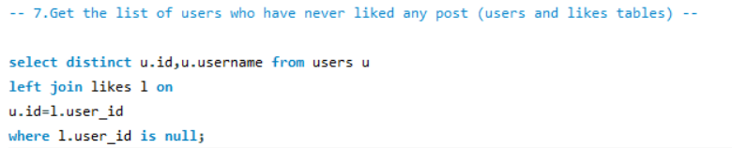

**OUTPUT**

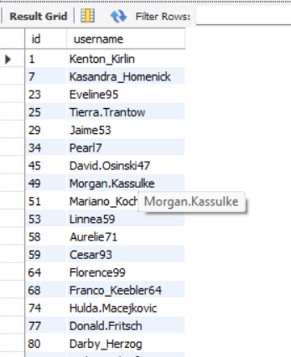

1. **How can you leverage user-generated content (posts, hashtags, photo tags) to create more personalized and engaging ad campaigns?**  
   **Ans-** This query calculates the average number of likes for photos associated with each tag. It starts by determining the total likes per photo and then averages these totals across all photos linked to each tag. The results are grouped by tag name and sorted in descending order of average likes. Finally, the top 10 tags with the highest average likes are selected and displayed.

**Query:**

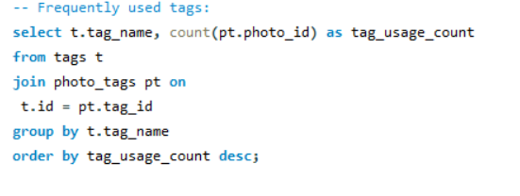

**OUTPUT**

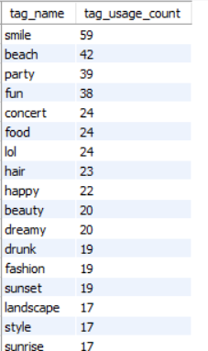

This query determines the frequency of each tag used in photos by joining the tags and photo_tags tables, linking tags with their respective photos. It then groups the results by tag name to calculate the total usage count for each tag. To highlight the most commonly used tags, the query sorts them in descending order based on their frequency. The final output presents each tag's name along with the number of times it has been used.

**Query: Output:**

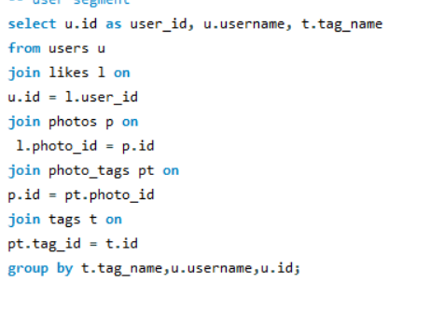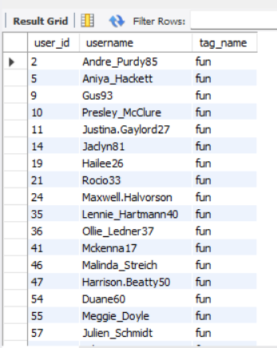

1. **Are there any correlations between user activity levels and specific content types (e.g., photos, videos, reels)? How can this information guide content creation and curation strategies?**

**Ans-** This query calculates the total number of photos, comments, and likes for each user, categorizing their primary type of engagement. It combines data from the users, photos, comments, and likes tables to identify whether a user is more active in posting photos, commenting, or liking content. The final output includes the user ID, username, counts of photos, comments, likes, and their predominant engagement type, highlighting user interaction patterns.

**Query:**

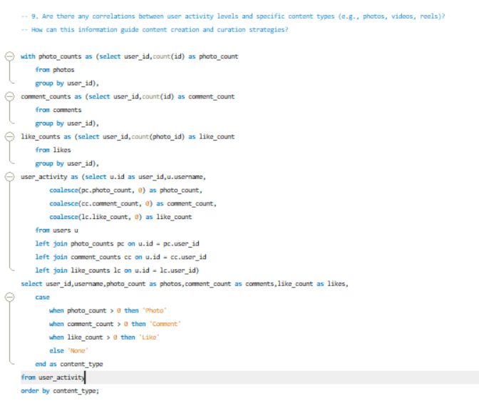

**OUTPUT**

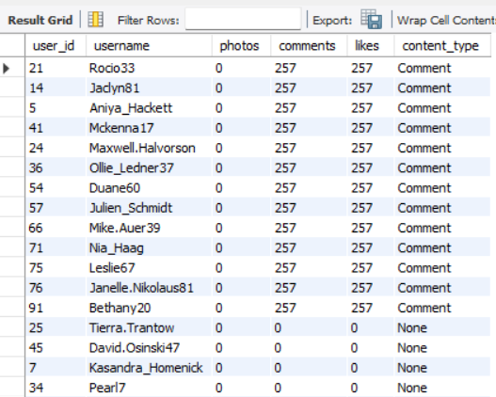 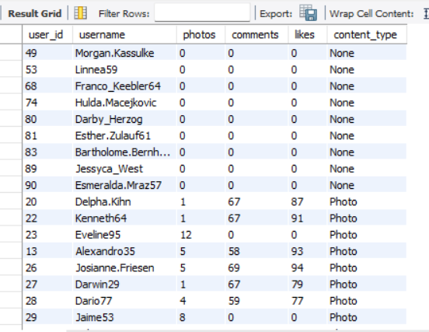

1. **High Comment Activity**:
   * Some users are primarily engaged in commenting, with a content_type labeled as "Comment" and a high comment_count, but no photo_count.
   * Example: "Rocio33" has 257 comments but zero photos, indicating a preference for engaging through comments rather than posting photos.
   * 13 out of 100 users are classified under "Comment" content_type.
2. **High Photo Activity**:
   * The majority of users have a content_type labeled as "Photo," with a high photo_count and varying comment_count.
   * Example: "Cesar93" has 10 photos and no comments, suggesting a preference for sharing photos over commenting.
   * 74 out of 100 users are categorized under "Photo" content_type.
3. **Inactive Users**:
   * Some users have not engaged in any content, resulting in a content_type labeled as "None."
   * 13 out of 100 users, or 13%, are inactive, showing no engagement in either comments or photos.
4. **Engaged Users**:
   * Out of the total 100 users, 87% are active, engaging in either comments or photos.
   * 13% of users engage primarily through comments.
   * 74% of users are more active in posting photos.

**Correlation Insights**:

* **Content Preference**: Users tend to specialize in either commenting or posting photos. There is a distinct divide between those who prefer contributing through photos and those who favor commenting. The analysis indicates that the majority of users are more engaged in the "Photo" content_type.

1. **Calculate the total number of likes, comments, and photo tags for each user.**

**Ans-** This query aggregates the total likes, comments, and photo tags for each user on the platform, combining these figures with user details. It ensures that users with no activity are still represented, with their counts set to zero.

**Query:**

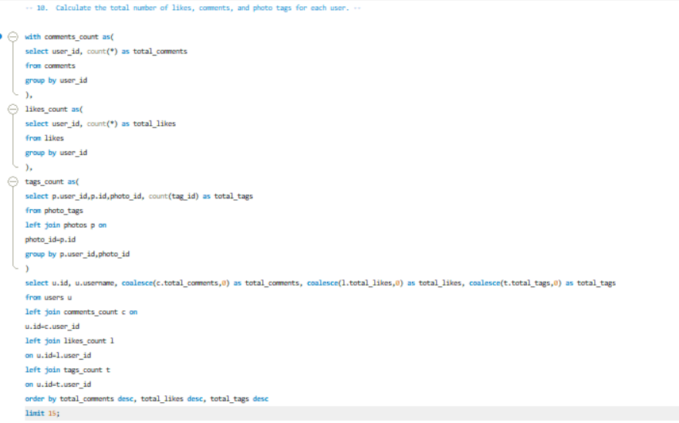

**OUTPUT**

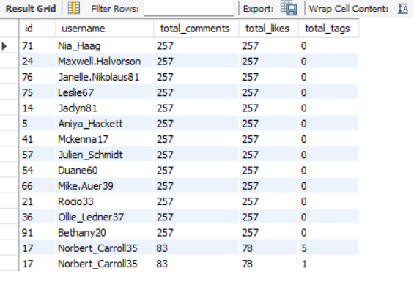

1. **Rank users based on their total engagement (likes, comments, shares) over a month.**

**Ans-** This query calculates and ranks user engagement for the past month by aggregating the total likes, comments, and tags associated with each user's photos. It sums these values to determine a total engagement score and ranks users accordingly, with the highest engagement ranked first. The output includes each user's ID, username, total likes, comments, tags, and their engagement rank.

**Query:**

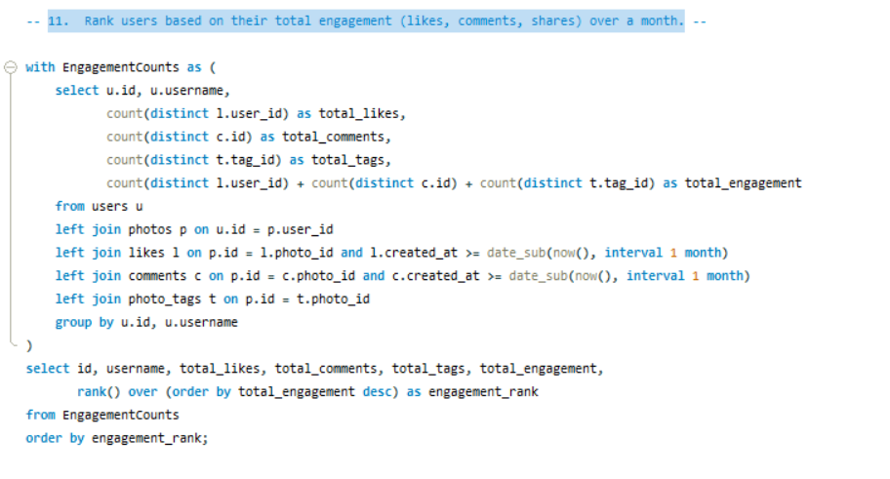

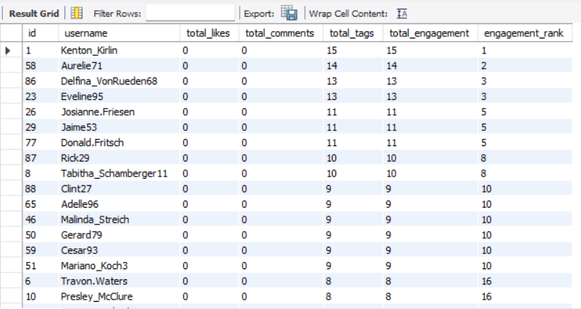

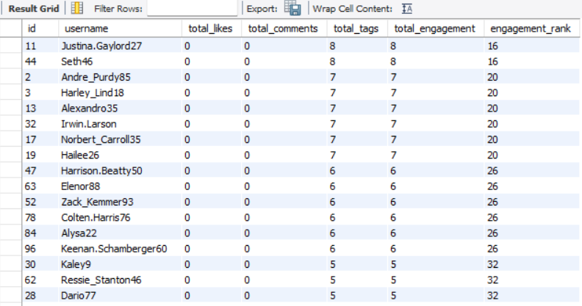

1. **Retrieve the hashtags that have been used in posts with the highest average number of likes. Use a CTE to calculate the average likes for each hashtag first.**

**Ans-** This query calculates the average likes for photos associated with each tag. It begins by summing the likes for each photo and then averages these totals across all photos linked to each tag. The results are grouped by tag name and sorted by average likes in descending order. Finally, the top 10 tags with the highest average likes are displayed.

**Query:**

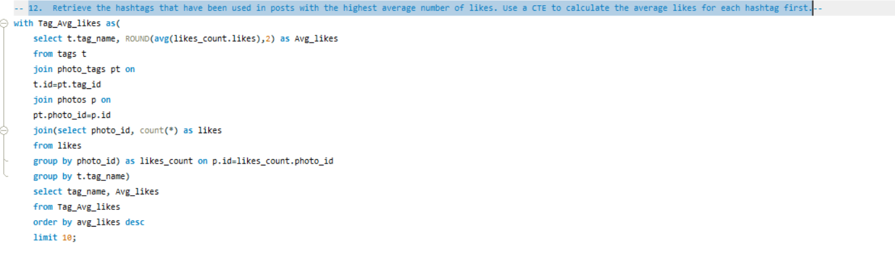

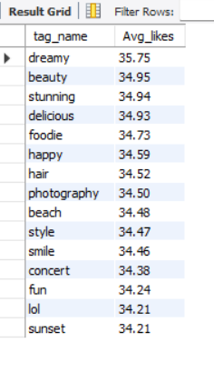

1. **Retrieve the users who have started following someone after being followed by that person**

**Ans-** This query identifies pairs of users who follow each other, where one user followed the other first. It matches users based on their follow relationships and compares timestamps to ensure that the second user followed after the first. The query returns the usernames of both users, labeled as "follower" and "followee," for pairs where reciprocal following took place.

**Query:**

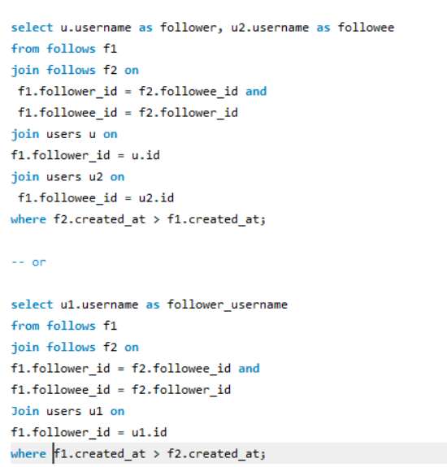

**Output**

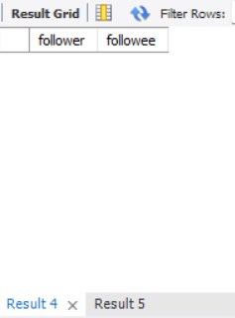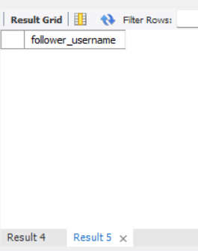

**Subjective Questions**

1. **Based on user engagement and activity levels, which users would you consider the most loyal or valuable? How would you reward or incentivize these users?**

**Ans-** This query calculates and ranks users by their overall engagement on a platform. It combines several activity metrics, such as the number of photos posted, comments made, likes given, followers, and following count, to compute an engagement score for each user. Users are ranked in descending order based on this engagement score. The final result displays the user ID, username, engagement score, and rank, but only for the user with the highest engagement score (rank 1).

**Query:**

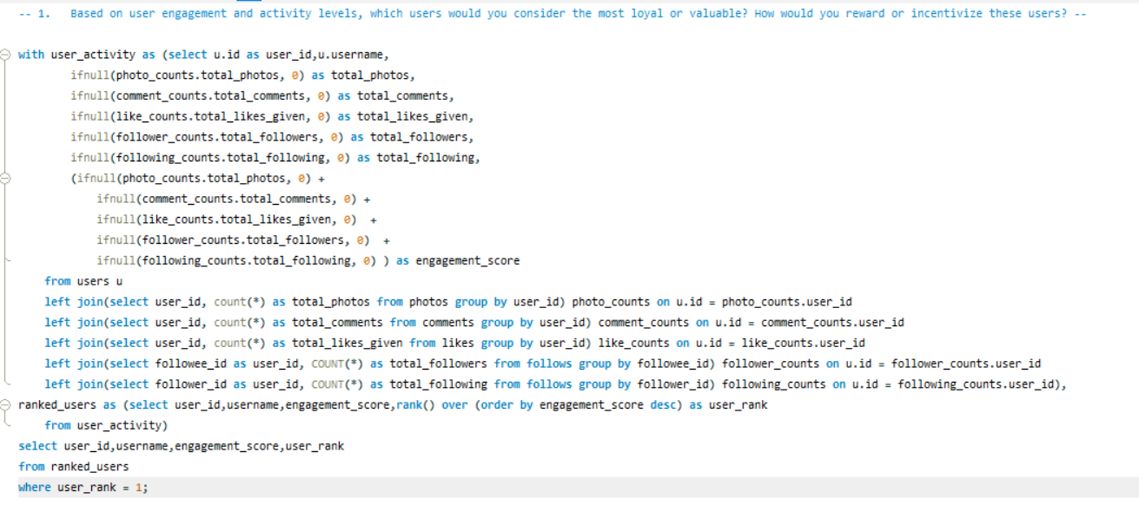

**OUPTPUT:**

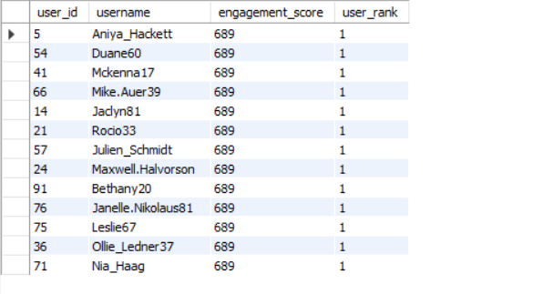

* The most loyal and valuable users are: Aniya_Hackett, Duane60, Mckenna17, Mike.Auer39, Jaclyn81, Rocio33, Julien_Schmidt, Maxwell.Halvorson, Bethany20, Janelle.Nikolaus81, Leslie67, Ollie_Ledner37, and Nia_Haag.
* This list is determined based on each user's engagement score, which takes into account the total photos uploaded, comments made, likes given, total following, and total followers.

**Ways to Reward and Incentivize Users :**

1. **Gift Cards and Discounts**  
   Offering gift cards or discounts is a popular and highly effective way to reward valuable users. These incentives encourage users to engage more with the platform by providing exciting and tangible benefits.
2. **Exclusive Access to Tools or Features**  
   Granting access to special tools or features can support valuable users in their growth and simplify their experience. For example, providing engagement insights or analytics can help them better understand their audience and optimize their performance.
3. **Invitations to Events**  
   Inviting users to attend platform-hosted events fosters community connection, helps them expand their network, and builds a stronger bond with the platform.
4. **Custom Badges or Titles**  
   Awarding personalized badges or titles recognizes users' contributions and highlights them within the community, boosting their visibility and sense of achievement.

**2. For inactive users, what strategies would you recommend to re-engage them and encourage them to start posting or engaging again?**

**Ans -** This query identifies and ranks users with the lowest engagement on the platform. It combines various activity metrics, including the number of photos posted, comments made, likes given, followers, and following, into a single engagement score. Users are ranked in ascending order of this score, with the user having the lowest engagement score ranked highest (rank 1). The output displays the user ID, username, engagement score, and rank, focusing on the user with the lowest engagement score.

**Query:**

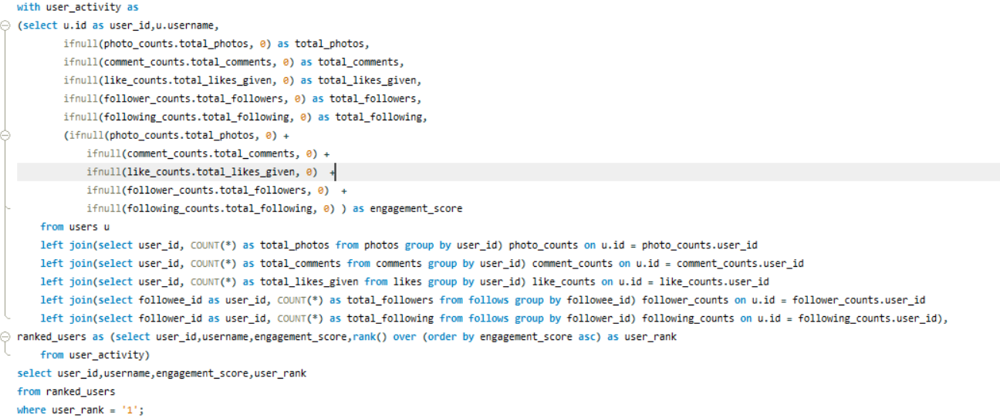

**OUTPUT**

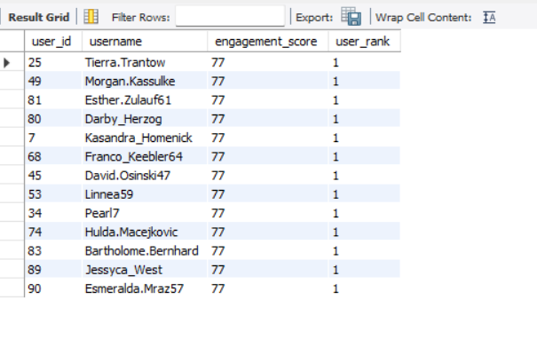

**Strategies to Encourage Inactive Users to Re-engage**

1. **Personalized Re-engagement Emails**
   * Highlight Missed Opportunities: Send tailored emails showcasing trending content or posts from their connections that they may have missed.
   * Recommendations: Suggest content, groups, or hashtags aligned with their past activity and interests.
2. **In-App Notifications**

* Milestone Reminders: Notify users of milestones they are close to achieving, such as reaching a certain number of followers or likes.

1. **Incentivize Engagement**

* Gamification: Create challenges or contests with rewards for the most engaging content or achieving specific activity milestones.

1. **Simplify the User Experience**

* Content Creation Prompts: Provide prompts or templates to make it easier for users to create and share content.
* Onboarding Refresh: Offer a guided re-onboarding experience to reacquaint users with platform features and benefits**.**

1. **Engagement-Focused Campaigns**

* Themed Weeks or Events: Host themed content weeks or virtual events to encourage participation and interaction.

1. **Feedback Loops**

* User Surveys: Gather feedback from inactive users to understand why they disengaged and address their concerns with meaningful changes or solutions.

1. **Enhanced Content Discovery**

* Explore Pages: Improve content discovery by curating personalized explore pages featuring trending or relevant content based on the user’s past preferences.

**3. Which hashtags or content topics have the highest engagement rates? How can this information guide content strategy and ad campaigns?**

**Ans-** This query identifies the top 10 tags with the highest average engagement on the platform. It calculates the total posts, likes, and comments associated with each tag, then computes the average engagement per post. The tags are ranked in descending order based on their average engagement.

**Query:**

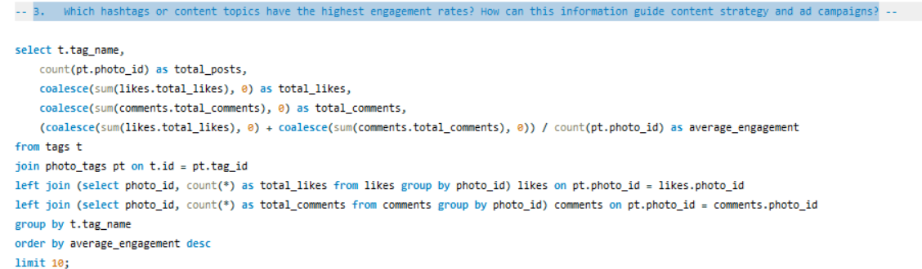

**OUTPUT**

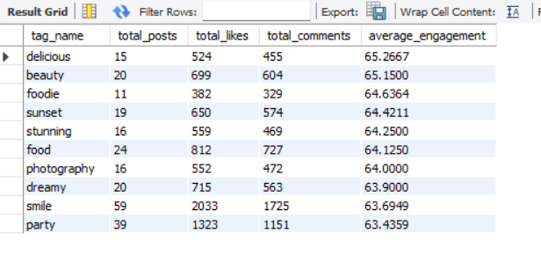

**1. Content Creation and Curation**

* Leverage Popular Themes: Create and curate content that aligns with high-engagement hashtags. For example, prioritize posts related to food (#delicious, #food, #foodie), beauty (#beauty, #stunning), and photography (#photography, #sunset).
* Encourage User-Generated Content (UGC): Motivate users to create content around these hashtags. Running a campaign inviting users to share their favorite #sunset or #foodie moments can significantly boost engagement.

**2. Ad Targeting and Campaigns**

* Ad Copy and Creative: Integrate these hashtags into ad copy and visual content. For instance, an ad promoting a new product could highlight its connection to the #beauty or #foodie lifestyle.
* Influencer Collaborations: Collaborate with influencers who frequently use these hashtags and enjoy high engagement. Partnering with a food influencer under #delicious or #foodie can drive targeted traffic and increase engagement.
* Hashtag-Based Ad Targeting: Use these hashtags to target ads to users who have interacted with similar content. This ensures that the ads are shown to an audience already interested in the relevant topics.

**3. Engagement Optimization**

* Create Trending Content Series: Develop a content series around popular hashtags, such as a weekly post featuring #sunset or #party. This will keep followers engaged and encourage them to return for new content.
* Cross-Promotion: Promote content featuring these hashtags across various social media platforms, driving more traffic and engagement to Instagram.
* Optimal Posting Times and Frequency: Analyze the best times and frequency for posting content with these hashtags. For example, sharing #sunset content in the evening may resonate better with users.

**4. Content Discovery and Algorithm Boost**

* Hashtag Usage for Algorithmic Advantage: Frequently use these high-engagement hashtags in posts to boost content discovery and improve algorithmic ranking. Posts with trending hashtags are more likely to be featured on the Explore page, expanding reach.
* Personalized Content Recommendations: Use insights from these hashtags to offer tailored content suggestions to users, improving their experience and driving higher engagement.

**4. Are there any patterns or trends in user engagement based on demographics (age, location, gender) or posting times? How can these insights inform targeted marketing campaigns**

**Ans-** This query analyzes photo engagement based on the hour of the day and day of the week. It groups photos by the hour they were posted, counting the total number of posts, likes, and comments for each hour. The average engagement per post (calculated as likes plus comments divided by the number of posts) is then computed and the results are sorted in descending order by this average engagement.

**Query:**

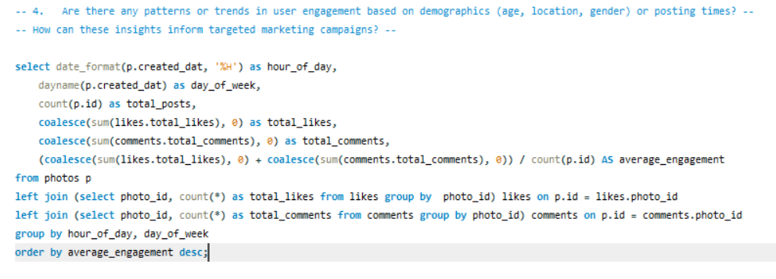

**OUTPUT**

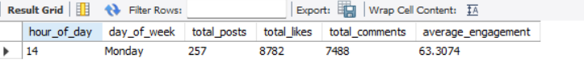

* The output above reveals that the highest user engagement occurs at 10 AM on Tuesdays, with an average engagement of 63.3.
* With a total of 257 posts, 8,782 likes, and 7,488 comments, the average engagement rate for approximately 100 users who predominantly post at 10 AM on Tuesdays has been calculated.
* Based on this analysis, since user engagement is highest during this specific time and day, this pattern can be leveraged for targeted ad marketing.
* Clear patterns and trends in user engagement emerge based on demographics. For instance, posts featuring sunsets, reels, and videos with hashtags like #sunset, #evening, and #photography will gain more reach when posted in the evening, as the content will resonate better with users at that time.
* Additionally, age and gender play a significant role, as different age groups are attracted to and engage with varying types of content.

1. **Based on follower counts and engagement rates, which users would be ideal candidates for influencer marketing campaigns? How would you approach and collaborate with these influencers?**

**Ans-** This query ranks users according to their engagement rate. It calculates the number of followers for each user and aggregates the total likes and comments on their photos. The engagement rate is determined by dividing the total engagement (likes plus comments) by the number of followers, with a special condition to handle users with zero followers. The results are sorted by engagement rate in descending order, with ties broken by follower count. The query retrieves the top 10 users with the highest engagement rates, displaying their user ID, username, follower count, total likes, total comments, total engagement, and engagement rate.

**Query:**

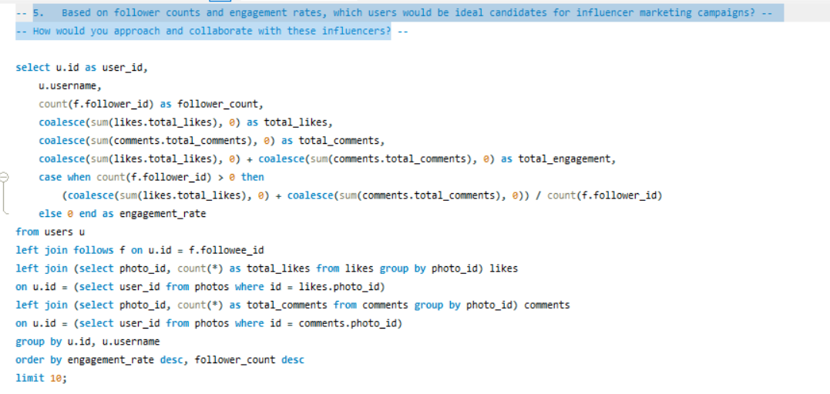

**OUTPUT:**

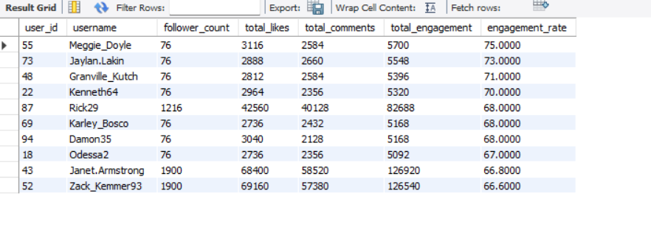

**Approaching and Collaborating with Influencers:**

1. **Research and Personalization**
   * Gain a deep understanding of the influencer’s content and their audience.
   * Personalize your outreach by referencing specific posts or campaigns that align with your brand’s values and goals.
2. **Collaboration Strategy**
   * Establish clear objectives for the campaign to ensure mutual alignment.
   * Offer influencers creative freedom within established content guidelines to maintain authenticity and originality.
3. **Compensation and Incentives**
   * Provide fair compensation, whether monetary or through product gifting.
   * Consider forming long-term partnerships to foster sustained engagement and collaboration.
4. **Tracking and Amplification**
   * Define clear KPIs (Key Performance Indicators) to assess the campaign’s success.
   * Maximize reach by amplifying influencer content across your brand’s own channels.
5. **Based on user behavior and engagement data, how would you segment the user base for targeted marketing campaigns or personalized recommendations?**

**Ans -** This SQL query calculates and categorizes user engagement on the platform. It begins by selecting user details such as user_id and username from the users table. The query then aggregates interaction data by joining the likes and comments tables to compute the total likes and comments for each user. It also counts the number of photos each user has posted from the photos table.

* The engagement rate is determined by dividing the total likes and comments by the number of photos.
* Based on the engagement rate, users are classified into 'High', 'Medium', or 'Low' engagement categories.

The data is grouped by user and the results are ordered in descending order by engagement rate. This query provides valuable insights into user activity and helps identify varying engagement levels among users.

**Query:**

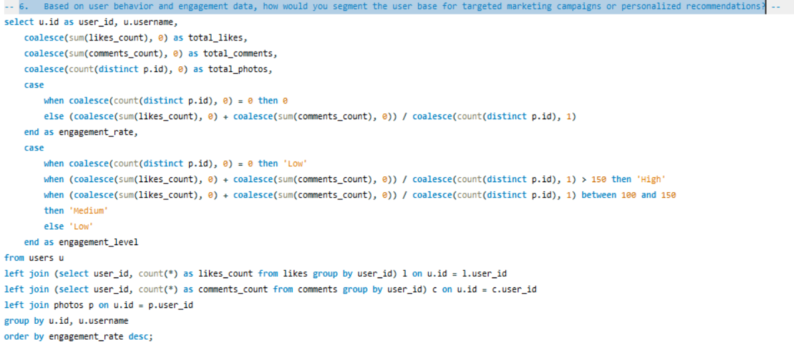

**OUTPUT:**

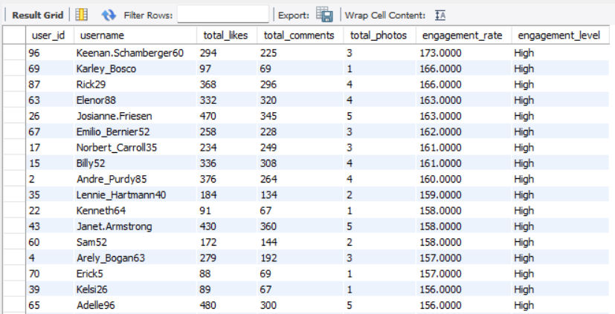

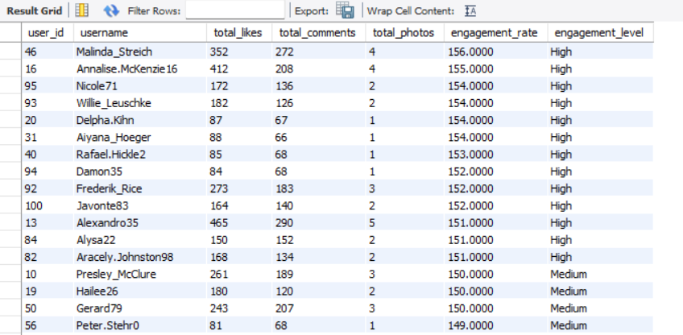

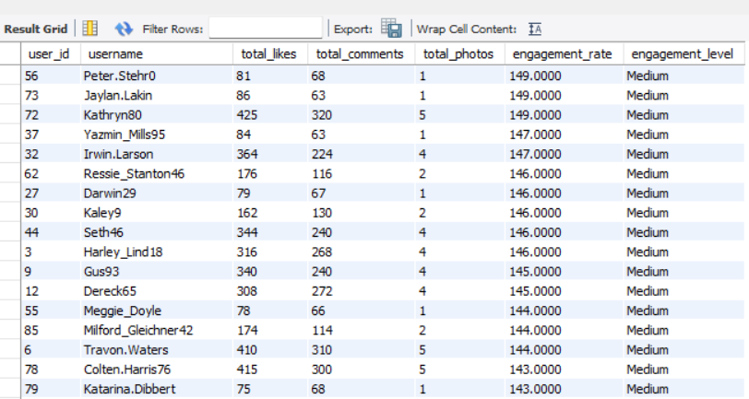

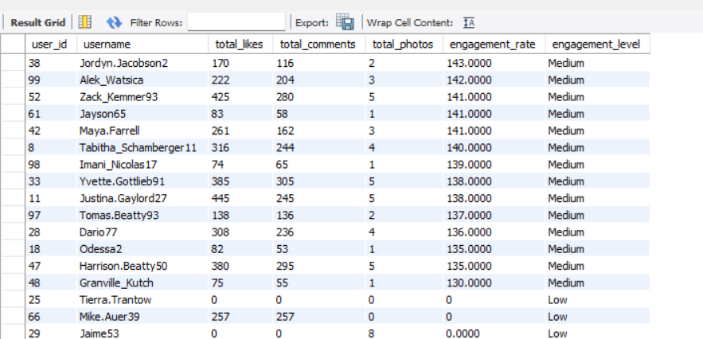 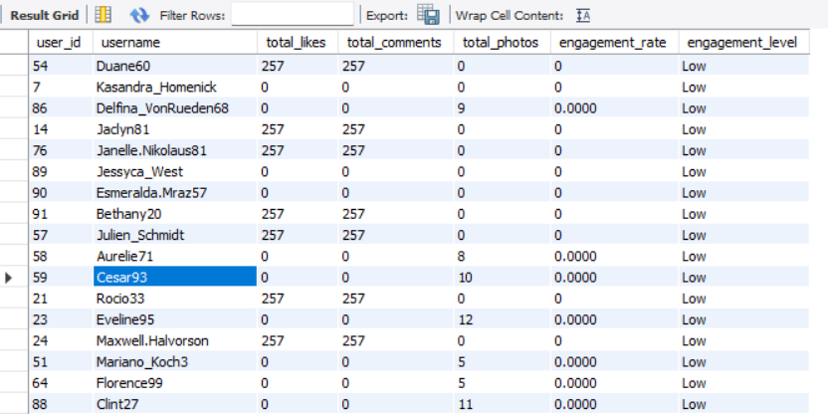

* 30% of users are classified as high engagement users, meaning 30 out of 100 users are highly engaged.
* 34% of users are medium engagement users, meaning 34 out of 100 users fall into this category.
* 36% of users are low engagement users, meaning 36 out of 100 users are considered low-engaged.

**Strategies for Targeted Marketing and Personalized Recommendations:**

1. **High Engagement Users**
   * Marketing Campaigns: Offer exclusive deals or early access to new products. Highlight premium features or products that align with their interests and activity patterns.
   * Personalized Recommendations: Suggest content, products, or services similar to what they frequently engage with. Tailor notifications and updates based on their preferences and past interactions.
2. **Medium Engagement Users**
   * Marketing Campaigns: Run targeted ads to encourage more engagement, such as special promotions or interactive content. Offer incentives like limited-time discounts to drive higher interaction.
   * Personalized Recommendations: Recommend content or products that align with their past behavior but introduce new or trending options to spark more engagement.
3. **Low Engagement Users**
   * Marketing Campaigns: Focus on re-engagement strategies. Offer discounts, reminders, or educational content to reignite their interest. Consider using win-back campaigns with personalized messages.
   * Personalized Recommendations: Introduce them to popular or engaging content and products. Use prompts or curated suggestions to capture their attention and encourage more interaction.

**Implementation Steps:**

1. Data Analysis: Continuously analyze user behavior and engagement metrics to refine segmentation and keep track of evolving trends.
2. Custom Messaging: Develop targeted messages and offers tailored to each segment’s interests and characteristics.
3. A/B Testing: Test different approaches within each segment to identify the most effective strategies.
4. Monitor and Adjust: Track the success of campaigns and recommendations. Use insights from feedback and results to make adjustments and enhance effectiveness.

By leveraging user behaviour and engagement data, you can design more impactful marketing campaigns and deliver personalized recommendations that resonate with each user segment.

1. **If data on ad campaigns (impressions, clicks, conversions) is available, how would you measure their effectiveness and optimize future campaigns?**

**Ans-**

* 1. **Measuring Campaign Effectiveness:**
* **Key Performance Indicators (KPIs):**
  + Impressions: Monitor the number of times an ad is shown to users. High impressions with low engagement may indicate the need for better audience targeting.
  + Click-Through Rate (CTR): Calculate CTR by dividing clicks by impressions. A low CTR suggests that the ad's creative or copy might need adjustment.
  + Conversion Rate: Track the percentage of clicks that result in a desired action (e.g., purchase, signup). This reflects how effective the ad is in generating meaningful outcomes.
* **Return on Ad Spend (ROAS):**
  + ROAS Calculation: Calculate ROAS by dividing the revenue generated from the campaign by the cost of the ads. A higher ROAS indicates a more profitable campaign.
  + Customer Acquisition Cost (CAC): Measure the cost of acquiring a new customer through the campaign. Compare CAC with the Customer Lifetime Value (CLV) to evaluate long-term profitability.
* **Impression Share:**
  + Track the percentage of impressions your ad receives compared to the total available impressions. A higher share indicates your ad is displayed more frequently in relevant contexts.
  + Use this data to assess visibility and compare performance against competitors.
* **Bounce Rate:**
  + Measure the percentage of users who click on your ad but leave the landing page without further engagement. A high bounce rate may suggest a mismatch between the ad content and landing page relevance.
  + Optimize landing pages to better align with the expectations set by the ad.

**2. Optimizing Future Campaigns:**

* **Ad Creative Optimization:**
  + Regularly refresh ad creatives (images, videos, copy) to prevent ad fatigue and sustain user interest.
  + Use insights from top-performing creatives to guide design and messaging for future campaigns.
* **Budget Allocation:**
  + Analyze which campaigns or channels provide the best ROAS and adjust your budget accordingly. Focus more on high-performing ads or audience segments.
  + Adjust bidding strategies (manual vs. automated) to maximize efficiency based on the campaign’s goals.
* **Frequency Capping:**
  + Implement frequency capping to limit the number of times a user sees your ad. This helps prevent ad fatigue and enhances user experience.
  + Test different frequency caps to determine the optimal balance between exposure and engagement.
* **Landing Page Optimization:**
  + Continuously improve landing pages using user behavior data (e.g., heatmaps, session recordings). Focus on fast load times, clear calls-to-action (CTAs), and mobile optimization.
  + Ensure landing page content aligns with the ad message to boost relevance and conversion rates.
* **Cross-Channel Attribution:**
  + Use attribution models (e.g., first-click, last-click, linear) to understand how different channels (e.g., social media, search, display) contribute to conversions**.**
  + Optimize campaign strategies by investing in the channels that most effectively drive the customer journey.

1. **How can you use user activity data to identify potential brand ambassadors or advocates who could help promote Instagram's initiatives or events?**

**Ans- To identify potential brand ambassadors or advocates:**

* High Engagement Users: Look for users who consistently engage with content (e.g., likes, comments, shares) and have a notable presence within specific niches or communities. These users are likely to hold influence within their circles.
* Content Creators: Identify users who regularly produce high-quality, original content that aligns with Instagram’s brand values. These users can naturally advocate for the platform through their creative output.
* Positive Sentiment: Utilize sentiment analysis to spot users who frequently share positive feedback about Instagram and its features. These users are genuine advocates who can authentically promote the brand.
* Frequent Interactions: Track users who engage regularly with Instagram’s official account or discuss Instagram on other platforms. Their ongoing participation and enthusiasm make them ideal candidates for brand advocacy.
* Personalized Outreach: Reach out with a message that emphasizes their influence and how their values align with Instagram’s initiatives.
* Value Proposition: Offer incentives like exclusive access, new features, or rewards for participating in campaigns.
* **Collaboration:**
* Set Clear Expectations: Clearly define campaign goals, the type of content expected, and how they can share their involvement.
* Offer Creative Freedom: Give them the flexibility to create content in their own style to maintain authenticity.
* Long-Term Partnership: Consider building lasting relationships with top-performing ambassadors for ongoing promotion of future campaigns or events.

1. **How would you approach this problem, if the objective and subjective questions weren't given?**

**Ans - Approach:**

* **Understanding and Analyzing Data:**
  1. Begin by thoroughly examining the data, as it plays a crucial role in addressing the question at hand. In this case, the dataset includes information for only 100 users, which is somewhat limited.
* **Identifying Key Metrics:**
  1. Engagement Metrics: Calculate each user's engagement rate by assessing likes, comments, tags, and photos. Also, analyze follower and following counts to identify emerging influencers and creators.
  2. Retention Metrics: Focus on identifying active users who consistently engage with the platform over various time frames (e.g., weekly, monthly, yearly). Recognizing inactive users will help in designing campaigns and events aimed at re-engaging them by understanding their preferences.
  3. Acquisition Metrics: Examine the growth of new users and the role that high-engagement users play in attracting these newcomers.
* **User Segmentation and Targeted Marketing:**
  1. Segment by Engagement Level: Classify users based on their activity level (e.g., highly active, moderately active, inactive). Identify those with a large following and high engagement rates as potential brand ambassadors.
  2. Personalized Content: Leverage segmentation to deliver tailored content recommendations for different user groups. Target inactive or low-engagement users with re-engagement campaigns, such as reminder emails or in-app notifications.
* **Analyzing Trends and Their Impact on Engagement:**
  1. Hashtag Analysis: Examine the hashtags used by users, including the most liked and most frequently used ones. This helps understand the topics that attract users and hold their attention on the platform.
  2. Influencer Identification: Based on the hashtags analyzed, identify potential influencers for each trend. Design campaigns targeting specific user groups associated with these trends.
  3. Predictive Models: Create models to predict user churn, identify potential influencers, or forecast viral content.
  4. Example Campaign: Since #smile is a popular hashtag, the marketing team can launch a campaign like #beauty_is_in_smile, encouraging users to post smiling photos using this hashtag along with others like #positivevibes and #happiness. This strategy would boost user engagement and foster growth.
* **Feedback:**
  1. User Insights: Utilize techniques like click tracking and browsing data to gain deeper insights into user preferences and behavior. This helps tailor content to what users are actively seeking.
  2. Campaign Feedback: Collect feedback on past campaigns to assess their effectiveness and identify areas for improvement. Use these insights to enhance future campaigns.
  3. Continuous Improvement: Incorporating feedback is vital to the process, as it allows for the refinement and optimization of ongoing and future initiatives.

1. **Assuming there's a "User_Interactions" table tracking user engagements, how can you update the "Engagement_Type" column to change all instances of "Like" to "Heart" to align with Instagram's terminology?**

**Ans – Query**

UPDATE User_Interactions

SET Engagement_Type = 'Heart'

WHERE Engagement_Type = 'Like';

**Steps to Implement the Update:**

1. **Check for Consistency**: Ensure that "Like" is the only term used within the database for engagement types to guarantee a thorough and complete update.
2. **Apply the Update**: Execute the update to replace "Like" with "Heart" in the Engagement_Type column, ensuring consistency across all relevant records.
3. **Test the Change**: Conduct tests in a staging or controlled environment to verify that the update does not negatively impact platform functionality or user experience.
4. **Notify Users**: Inform users about the change in terminology, explaining the reason behind the update and how it may impact their interactions. This can be communicated through in-app messages or public announcements.
5. **Monitor the Impact**: After implementing the update, monitor user interactions and system performance to confirm that the change was applied successfully and that users are adapting to the new terminology.